**Multi-phenotype inter-functional clustering visualization results**

Jin Chen -- Jan 25 2016

Software: NPM and OLIVER

Data: Phi2, qESV and qI from DEPI, gene information from TAIR * only positive qI logged fold change values are used

Flat light, cluster 1: high Phi2, mid qE, mid qI

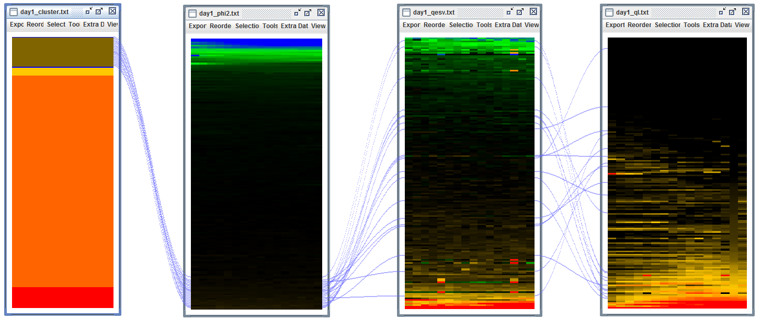

|  |  |
| --- | --- |
| Locus Identifier | Gene Model Description |
| AT2G21160 | Translocon-associated protein (TRAP), alpha subunit; INVOLVED IN: biological_process unknown; LOCATED IN: chloroplast thylakoid membrane, endoplasmic reticulum, plasma membrane, vacuole; EXPRESSED IN: 27 plant structures; EXPRESSED DURING: 15 growth stages; CONTAINS InterPro DOMAIN/s: Translocon-associated protein (TRAP), alpha subunit (InterPro:IPR005595); BEST Arabidopsis thaliana protein match is: Translocon-associated protein (TRAP), alpha subunit (TAIR:AT2G16595.1); Has 246 Blast hits to 246 proteins in 95 species: Archae - 0; Bacteria - 0; Metazoa - 141; Fungi - 24; Plants - 60; Viruses - 0; Other Eukaryotes - 21 (source: NCBI BLink). |
| AT1G78915 | Tetratricopeptide repeat (TPR)-like superfamily protein; FUNCTIONS IN: binding; INVOLVED IN: biological_process unknown; LOCATED IN: chloroplast thylakoid membrane; CONTAINS InterPro DOMAIN/s: Tetratricopeptide-like helical (InterPro:IPR011990), Tetratricopeptide repeat-containing (InterPro:IPR013026), Tetratricopeptide repeat (InterPro:IPR019734). |
| AT1G50450 | Saccharopine dehydrogenase ; FUNCTIONS IN: binding, catalytic activity; INVOLVED IN: metabolic process; LOCATED IN: chloroplast; EXPRESSED IN: 21 plant structures; EXPRESSED DURING: 13 growth stages; CONTAINS InterPro DOMAIN/s: Saccharopine dehydrogenase / Homospermidine synthase (InterPro:IPR005097), NAD(P)-binding domain (InterPro:IPR016040); Has 1549 Blast hits to 1547 proteins in 500 species: Archae - 22; Bacteria - 980; Metazoa - 33; Fungi - 88; Plants - 49; Viruses - 0; Other Eukaryotes - 377 (source: NCBI BLink). |
| AT5G23890 | LOCATED IN: mitochondrion, chloroplast thylakoid membrane, chloroplast, plastid, chloroplast envelope; EXPRESSED IN: 24 plant structures; EXPRESSED DURING: 14 growth stages; CONTAINS InterPro DOMAIN/s: S-layer homology domain (InterPro:IPR001119); BEST Arabidopsis thaliana protein match is: unknown protein (TAIR:AT5G52410.2); Has 1807 Blast hits to 1807 proteins in 277 species: Archae - 0; Bacteria - 0; Metazoa - 736; Fungi - 347; Plants - 385; Viruses - 0; Other Eukaryotes - 339 (source: NCBI BLink). |
| AT1G42960 | expressed protein localized to the inner membrane of the chloroplast. |
| AT5G20140 | SOUL heme-binding family protein; CONTAINS InterPro DOMAIN/s: Protein of unknown function DUF2358 (InterPro:IPR018790), SOUL haem-binding protein (InterPro:IPR006917); BEST Arabidopsis thaliana protein match is: SOUL heme-binding family protein (TAIR:AT3G10130.1). |
| AT3G60370 | Encodes an immunophilin, FKBP20-2, that belongs to the FK-506 binding protein (FKBP) subfamily functioning as peptidyl-prolyl isomerases (PPIases) in protein folding. FKBP20-2 has a unique pair of cysteines at the C terminus and was found to be reduced by thioredoxin (Trx) (itself reduced by NADPH by means of NADP-Trx reductase). The FKBP20-2 protein, which contains only two of the five amino acids required for catalysis, showed a low level of PPIase activity that was unaffected on reduction by Trx. Genetic disruption of the FKBP20-2 gene provide evidence that FKBP20-2 participates specifically in the accumulation of the PSII supercomplex in the chloroplast thylakoid lumen by means of a mechanism that has yet to be determined. |
| AT5G52780 | Protein of unknown function (DUF3464); FUNCTIONS IN: molecular_function unknown; INVOLVED IN: biological_process unknown; LOCATED IN: chloroplast thylakoid membrane, chloroplast; EXPRESSED IN: 20 plant structures; EXPRESSED DURING: 13 growth stages; CONTAINS InterPro DOMAIN/s: Protein of unknown function DUF3464 (InterPro:IPR021855); BEST Arabidopsis thaliana protein match is: Protein of unknown function (DUF3464) (TAIR:AT4G19100.1); Has 1807 Blast hits to 1807 proteins in 277 species: Archae - 0; Bacteria - 0; Metazoa - 736; Fungi - 347; Plants - 385; Viruses - 0; Other Eukaryotes - 339 (source: NCBI BLink). |
| AT4G18370 | Encodes DEG5. Forms a hexamer with DEG8 in the thylakoid lumen. Involved in the cleavage of photodamaged D2 protein of photosystem II (PSII). |
| AT1G27510 | FUNCTIONS IN: DNA binding, nuclease activity; INVOLVED IN: response to singlet oxygen; LOCATED IN: thylakoid membrane; EXPRESSED IN: 22 plant structures; EXPRESSED DURING: 13 growth stages; CONTAINS InterPro DOMAIN/s: Protein of unknown function DUF3506 (InterPro:IPR021894), UvrB/UvrC protein (InterPro:IPR001943); BEST Arabidopsis thaliana protein match is: Protein of unknown function (DUF3506) (TAIR:AT4G33630.2); Has 287 Blast hits to 280 proteins in 95 species: Archae - 0; Bacteria - 15; Metazoa - 66; Fungi - 43; Plants - 121; Viruses - 0; Other Eukaryotes - 42 (source: NCBI BLink). |
| AT1G74880 | Encodes subunit NDH-O of NAD(P)H:plastoquinone dehydrogenase complex (Ndh complex) present in the thylakoid membrane of chloroplasts. This subunit is thought to be required for Ndh complex assembly. |
| AT4G23890 | unknown protein; FUNCTIONS IN: molecular_function unknown; INVOLVED IN: biological_process unknown; LOCATED IN: chloroplast thylakoid membrane, chloroplast; EXPRESSED IN: 22 plant structures; EXPRESSED DURING: 13 growth stages; CONTAINS InterPro DOMAIN/s: Protein of unknown function DUF3252 (InterPro:IPR021659); Has 287 Blast hits to 287 proteins in 81 species: Archae - 0; Bacteria - 118; Metazoa - 12; Fungi - 6; Plants - 40; Viruses - 0; Other Eukaryotes - 111 (source: NCBI BLink). |
| AT1G55370 | NDH-dependent cyclic electron flow 5 (NDF5); FUNCTIONS IN: carbohydrate binding, catalytic activity; INVOLVED IN: positive regulation of gene expression, photosynthetic electron transport in photosystem I; LOCATED IN: chloroplast, membrane; EXPRESSED IN: 21 plant structures; EXPRESSED DURING: 13 growth stages; CONTAINS InterPro DOMAIN/s: Glycoside hydrolase-type carbohydrate-binding (InterPro:IPR011013); BEST Arabidopsis thaliana protein match is: NDH-dependent cyclic electron flow 1 (TAIR:AT1G64770.1); Has 166 Blast hits to 165 proteins in 21 species: Archae - 0; Bacteria - 6; Metazoa - 0; Fungi - 0; Plants - 158; Viruses - 0; Other Eukaryotes - 2 (source: NCBI BLink). |
| AT1G18730 | likely a subunit of the chloroplast NAD(P)H dehydrogenase complex, involved in PSI cyclic electron transport. Located on the thylakoid membrane. Mutant has impaired NAD(P)H dehydrogenase activity. |
| AT3G01440 | Encodes a subunit of the NAD(P)H complex located in the chloroplast thylakoid lumen. |
| AT2G01140 | Aldolase superfamily protein; FUNCTIONS IN: fructose-bisphosphate aldolase activity; INVOLVED IN: response to oxidative stress, response to cadmium ion, pentose-phosphate shunt; LOCATED IN: mitochondrion, chloroplast, plastoglobule; EXPRESSED IN: 25 plant structures; EXPRESSED DURING: 15 growth stages; CONTAINS InterPro DOMAIN/s: Aldolase-type TIM barrel (InterPro:IPR013785), Fructose-bisphosphate aldolase, class-I (InterPro:IPR000741); BEST Arabidopsis thaliana protein match is: fructose-bisphosphate aldolase 2 (TAIR:AT4G38970.1); Has 4797 Blast hits to 4792 proteins in 909 species: Archae - 0; Bacteria - 723; Metazoa - 1159; Fungi - 8; Plants - 476; Viruses - 0; Other Eukaryotes - 2431 (source: NCBI BLink). |
| AT1G65260 | Encodes a protein required for thylakoid membrane formation. |
| AT2G01918 | Encode a protein homologous to each PQL protein. Mutational analysis indicates that PQL3 is also required for NDH activity. |
| AT5G42270 | VAR1 contains a conserved motif for ATPase and a metalloprotease characteristic to FtsH proteins, and is targeted into chloroplasts. A VAR1-fusion protein synthesized in vitro exhibited ATPase activity and partial metalloprotease activity. This protein is located to the thylakoid membrane and forms a complex with VAR2. FtsH1 (VAR1) and FtsH5 are interchangeable in thylakoid membranes. Phosphorylation of this protein is dependent on calcium. |

Flat light, cluster 2:low Phi2, low qE, mid qI

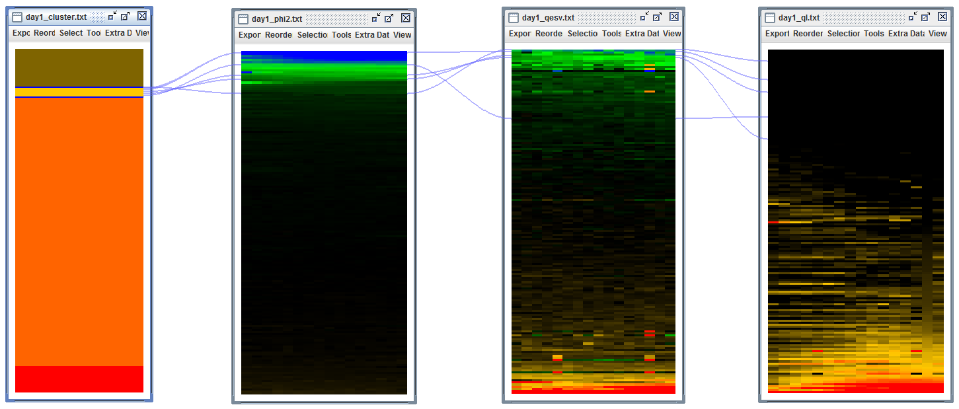

|  |  |
| --- | --- |
| AT1G22450 | subunit 6b of cytochrome c oxidase |
| AT1G73530 | RNA-binding (RRM/RBD/RNP motifs) family protein; FUNCTIONS IN: RNA binding, nucleotide binding, nucleic acid binding; INVOLVED IN: biological_process unknown; LOCATED IN: chloroplast; EXPRESSED IN: 22 plant structures; EXPRESSED DURING: 13 growth stages; CONTAINS InterPro DOMAIN/s: RNA recognition motif, RNP-1 (InterPro:IPR000504), Nucleotide-binding, alpha-beta plait (InterPro:IPR012677); BEST Arabidopsis thaliana protein match is: RNA-binding (RRM/RBD/RNP motifs) family protein (TAIR:AT5G54580.1); Has 7 Blast hits to 7 proteins in 2 species: Archae - 0; Bacteria - 0; Metazoa - 0; Fungi - 0; Plants - 7; Viruses - 0; Other Eukaryotes - 0 (source: NCBI BLink). |
| AT2G26550 | Encodes a heme oxygenase-like protein lacking the conserved histidine residue at the active site that is usually involved in heme-iron coordination. It is unable to bind and degrade heme. Mutant analyses suggest a role in photomorphogenesis. The protein can bind the heme precursor, proto IX, which could be biologically significant and point to a role in the regulation of the two tetrapyrrole biosynthetic pathways. |
| AT5G52440 | HCF106; nuclear gene for chloroplast. Thylakoid membrane delta pH translocation pathway component protein; related to Escherichia coli TatA and TatB |
| AT3G46610 | Pentatricopeptide repeat (PPR-like) superfamily protein; CONTAINS InterPro DOMAIN/s: Pentatricopeptide repeat (InterPro:IPR002885); BEST Arabidopsis thaliana protein match is: Pentatricopeptide repeat (PPR) superfamily protein (TAIR:AT5G14350.1); Has 35826 Blast hits to 11282 proteins in 257 species: Archae - 3; Bacteria - 23; Metazoa - 290; Fungi - 374; Plants - 33823; Viruses - 0; Other Eukaryotes - 1313 (source: NCBI BLink). |

Flat light cluster 3: mid Phi2, mid qE, mid qI

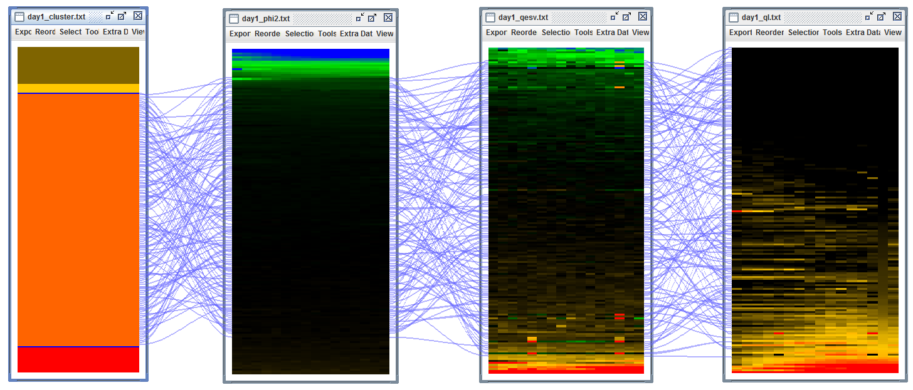

Flat light cluster 4: low Phi2, high qE, high qI

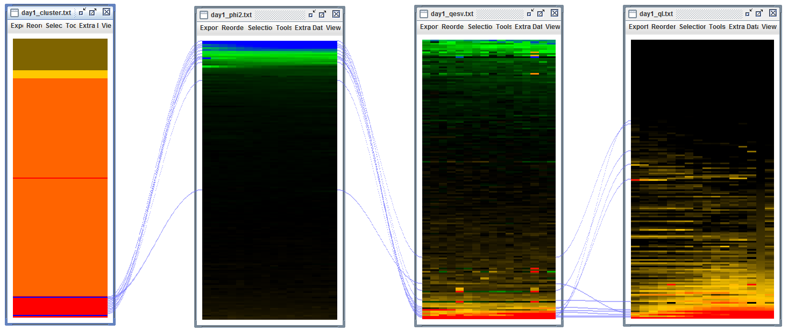

|  |  |
| --- | --- |
| Locus Identifier | Gene Model Description |
| AT2G26360 | Mitochondrial substrate carrier family protein; FUNCTIONS IN: binding; INVOLVED IN: transport, mitochondrial transport, transmembrane transport; LOCATED IN: mitochondrial inner membrane, membrane; EXPRESSED IN: 23 plant structures; EXPRESSED DURING: 13 growth stages; CONTAINS InterPro DOMAIN/s: Mitochondrial carrier protein (InterPro:IPR002067), Mitochondrial substrate carrier (InterPro:IPR001993), Mitochondrial substrate/solute carrier (InterPro:IPR018108); BEST Arabidopsis thaliana protein match is: mitochondrial substrate carrier family protein (TAIR:AT2G35800.1); Has 17043 Blast hits to 12636 proteins in 416 species: Archae - 0; Bacteria - 6; Metazoa - 6988; Fungi - 5263; Plants - 3119; Viruses - 0; Other Eukaryotes - 1667 (source: NCBI BLink). |
| AT3G17830 | Molecular chaperone Hsp40/DnaJ family protein; FUNCTIONS IN: unfolded protein binding, heat shock protein binding, ATP binding; INVOLVED IN: protein folding, response to heat; LOCATED IN: chloroplast; EXPRESSED IN: 8 plant structures; EXPRESSED DURING: 4 anthesis, F mature embryo stage, petal differentiation and expansion stage, E expanded cotyledon stage, D bilateral stage; CONTAINS InterPro DOMAIN/s: Molecular chaperone, heat shock protein, Hsp40, DnaJ (InterPro:IPR015609), HSP40/DnaJ peptide-binding (InterPro:IPR008971), Chaperone DnaJ, C-terminal (InterPro:IPR002939), Heat shock protein DnaJ, N-terminal (InterPro:IPR001623), Heat shock protein DnaJ, conserved site (InterPro:IPR018253), Heat shock protein DnaJ, cysteine-rich domain (InterPro:IPR001305), Chaperone DnaJ (InterPro:IPR012724), Heat shock protein DnaJ (InterPro:IPR003095); BEST Arabidopsis thaliana protein match is: Molecular chaperone Hsp40/DnaJ family protein (TAIR:AT1G80030.2); Has 28823 Blast hits to 28018 proteins in 3494 species: Archae - 196; Bacteria - 10926; Metazoa - 4489; Fungi - 2504; Plants - 2754; Viruses - 18; Other Eukaryotes - 7936 (source: NCBI BLink). |
| AT4G25050 | encodes an acyl carrier protein predominantly expressed in leaves. Gene expression is upregulated by light. |
| AT1G32500 | Encodes a member of a heterogenous group of non-intrinsic ATP-binding cassette (ABC) proteins. Members of this group bear no close resemblance to each other nor to representatives of specific ABC protein subfamilies from other organisms. This grouping is arbitrary and will likely change upon acquisition of further data. |
| AT4G36810 | Encodes a protein with geranylgeranyl pyrophosphate synthase activity involved in isoprenoid biosynthesis. The enzyme appears to be targeted to the chloroplast in epidermal cells and guard cells of leaves, and in etioplasts in roots. |
| AT2G41680 | Encodes a NADPH thioredoxin reductase involved in chloroplast protection against oxidative damage. |
| AT4G25910 | Encodes a protein containing the NFU domain that may be involved in iron-sulfur cluster assembly. Part of a five member gene family, more closely related to NFU1 and 2 than to NFU4 and 5. Targeted to the chloroplast. |
| AT3G47450 | Encodes a protein with similarity to the bacterial YqeH GTPase required for proper ribosome assembly. In Arabidopsis, mutant analyses show that this protein regulates growth and hormonal signaling in plants. It also attenuates oxidative stress and reactive oxygen species (ROS). It also seems to be involved in regulating leaf senescence and cell death. This gene product is also involved in nitric oxide biosynthesis in response to ABA but not exogenous H2O2. This protein also appears to be required for proper plastid biogenesis. Levels of several plastid-localized proteins, including RBCL, ClpP1, and the MEP biosynthesis enzymes DXS and DXR are altered in rif1-1 mutants. This protein was originally characterized as a mitrochondrial-localized nitric oxide synthase, but, the synthase activity was later disproven. In addition, new studies with GFP fusion proteins and chloroplast import assays suggest that this protein is found in chloroplasts. |
| AT4G33520 | Encodes a putative metal-transporting P-type ATPase. |
| AT2G18790 | Red/far-red photoreceptor involved in the regulation of de-etiolation. Exists in two inter-convertible forms: Pr and Pfr (active). Involved in the light-promotion of seed germination and in the shade avoidance response. |
| AT3G19490 | member of Na+/H+ antiporter-Putative family |
| AT1G54780 | Encodes a thylakoid lumen protein regulating photosystem II repair cycle. Has acid phosphatase activity. |

Flat day outlier 1: low Phi2, low qE and high q

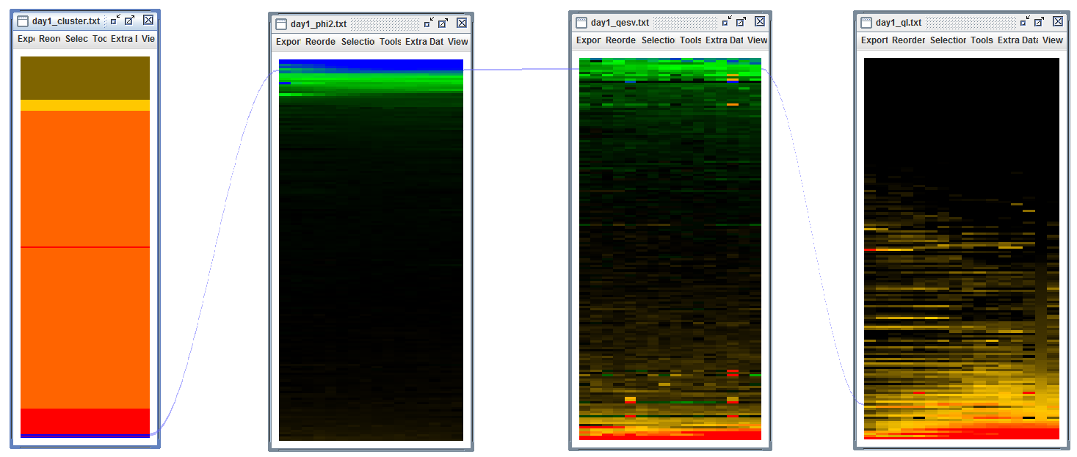

|  |  |
| --- | --- |
| Locus Identifier | Gene Model Description |
| AT3G01480 | Encodes a chloroplast cyclophilin functioning in the assembly and maintenance of photosystem II (PSII) supercomplexes. |

Sine light, cluster 1: Low Phi2, high qE, high qI

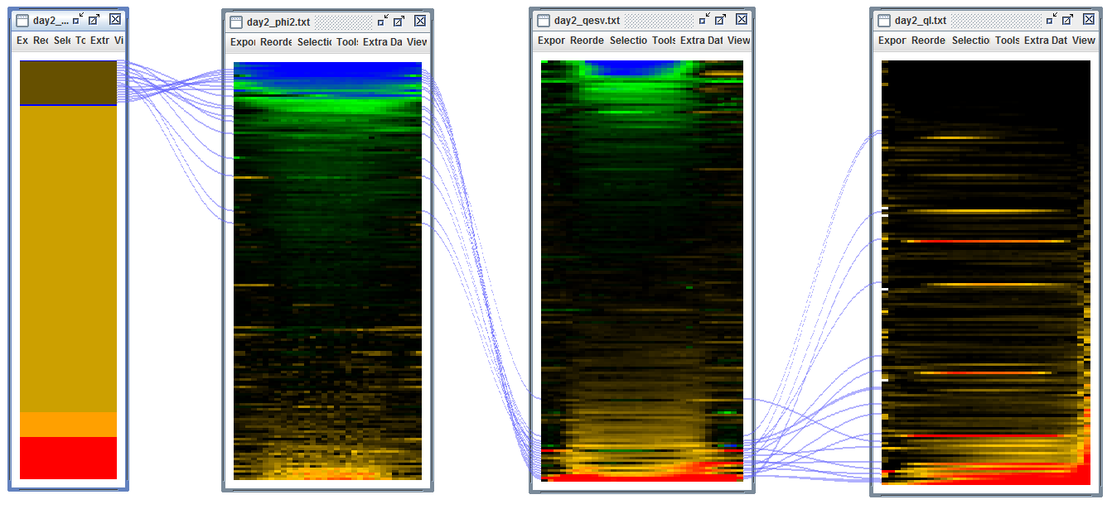

|  |  |
| --- | --- |
| Locus Identifier | Gene Model Description |
| AT2G30695 | FUNCTIONS IN: molecular_function unknown; INVOLVED IN: protein folding, protein transport; LOCATED IN: chloroplast stroma, chloroplast; EXPRESSED IN: 23 plant structures; EXPRESSED DURING: 13 growth stages; CONTAINS InterPro DOMAIN/s: Trigger factor, ribosome-binding, bacterial (InterPro:IPR008881); Has 253 Blast hits to 253 proteins in 72 species: Archae - 0; Bacteria - 138; Metazoa - 0; Fungi - 0; Plants - 40; Viruses - 0; Other Eukaryotes - 75 (source: NCBI BLink). |
| AT3G08920 | Rhodanese/Cell cycle control phosphatase superfamily protein; FUNCTIONS IN: molecular_function unknown; INVOLVED IN: biological_process unknown; LOCATED IN: chloroplast; EXPRESSED IN: 21 plant structures; EXPRESSED DURING: 13 growth stages; CONTAINS InterPro DOMAIN/s: Rhodanese-like (InterPro:IPR001763); BEST Arabidopsis thaliana protein match is: Rhodanese/Cell cycle control phosphatase superfamily protein (TAIR:AT2G42220.1); Has 237 Blast hits to 237 proteins in 53 species: Archae - 0; Bacteria - 52; Metazoa - 3; Fungi - 0; Plants - 146; Viruses - 0; Other Eukaryotes - 36 (source: NCBI BLink). |
| AT1G67700 | unknown protein; FUNCTIONS IN: molecular_function unknown; INVOLVED IN: biological_process unknown; LOCATED IN: chloroplast, chloroplast envelope; EXPRESSED IN: 22 plant structures; EXPRESSED DURING: 13 growth stages; Has 49 Blast hits to 49 proteins in 20 species: Archae - 0; Bacteria - 0; Metazoa - 0; Fungi - 0; Plants - 44; Viruses - 0; Other Eukaryotes - 5 (source: NCBI BLink). |
| AT1G32500 | Encodes a member of a heterogenous group of non-intrinsic ATP-binding cassette (ABC) proteins. Members of this group bear no close resemblance to each other nor to representatives of specific ABC protein subfamilies from other organisms. This grouping is arbitrary and will likely change upon acquisition of further data. |
| AT1G03160 | A new plant-specific member of the dynamin superfamily; defines a new protein class within the dynamin superfamily of membrane remodeling GTPases that regulates organization of the thylakoid network in plants. Targeted to chloroplasts and associated with thylakoid and envelope membranes as punctate structures. Knockout mutants have abnormalities in chloroplast and thylakoid morphology, including disorganized grana stacks and alterations in the relative proportions of grana and stroma thylakoids. Overexpression of FZL-GFP also conferred defects in thylakoid organization. |
| AT4G33010 | glycine decarboxylase P-protein 1 (GLDP1); FUNCTIONS IN: glycine dehydrogenase (decarboxylating) activity, protein binding; INVOLVED IN: glycine catabolic process, response to cadmium ion, glycine decarboxylation via glycine cleavage system; LOCATED IN: mitochondrion, apoplast, glycine cleavage complex, chloroplast, chloroplast envelope; EXPRESSED IN: 31 plant structures; EXPRESSED DURING: 16 growth stages; CONTAINS InterPro DOMAIN/s: Pyridoxal phosphate-dependent transferase, major domain (InterPro:IPR015424), Glycine cleavage system P-protein (InterPro:IPR003437), Glycine cleavage system P-protein-like (InterPro:IPR020581), Pyridoxal phosphate-dependent transferase, major region, subdomain 1 (InterPro:IPR015421), Glycine cleavage system P-protein, N-terminal (InterPro:IPR020580); BEST Arabidopsis thaliana protein match is: glycine decarboxylase P-protein 2 (TAIR:AT2G26080.1); Has 12463 Blast hits to 11454 proteins in 1943 species: Archae - 255; Bacteria - 5318; Metazoa - 139; Fungi - 214; Plants - 99; Viruses - 0; Other Eukaryotes - 6438 (source: NCBI BLink). |
| AT4G37925 | Encodes subunit NDH-M of NAD(P)H:plastoquinone dehydrogenase complex (Ndh complex) present in the thylakoid membrane of chloroplasts. This subunit is thought to be required for Ndh complex assembly. |
| AT3G01440 | Encodes a subunit of the NAD(P)H complex located in the chloroplast thylakoid lumen. |
| AT2G18790 | Red/far-red photoreceptor involved in the regulation of de-etiolation. Exists in two inter-convertible forms: Pr and Pfr (active). Involved in the light-promotion of seed germination and in the shade avoidance response. |
| AT3G19490 | member of Na+/H+ antiporter-Putative family |
| AT5G42270 | VAR1 contains a conserved motif for ATPase and a metalloprotease characteristic to FtsH proteins, and is targeted into chloroplasts. A VAR1-fusion protein synthesized in vitro exhibited ATPase activity and partial metalloprotease activity. This protein is located to the thylakoid membrane and forms a complex with VAR2. FtsH1 (VAR1) and FtsH5 are interchangeable in thylakoid membranes. Phosphorylation of this protein is dependent on calcium. |
| AT3G17830 | Molecular chaperone Hsp40/DnaJ family protein; FUNCTIONS IN: unfolded protein binding, heat shock protein binding, ATP binding; INVOLVED IN: protein folding, response to heat; LOCATED IN: chloroplast; EXPRESSED IN: 8 plant structures; EXPRESSED DURING: 4 anthesis, F mature embryo stage, petal differentiation and expansion stage, E expanded cotyledon stage, D bilateral stage; CONTAINS InterPro DOMAIN/s: Molecular chaperone, heat shock protein, Hsp40, DnaJ (InterPro:IPR015609), HSP40/DnaJ peptide-binding (InterPro:IPR008971), Chaperone DnaJ, C-terminal (InterPro:IPR002939), Heat shock protein DnaJ, N-terminal (InterPro:IPR001623), Heat shock protein DnaJ, conserved site (InterPro:IPR018253), Heat shock protein DnaJ, cysteine-rich domain (InterPro:IPR001305), Chaperone DnaJ (InterPro:IPR012724), Heat shock protein DnaJ (InterPro:IPR003095); BEST Arabidopsis thaliana protein match is: Molecular chaperone Hsp40/DnaJ family protein (TAIR:AT1G80030.2); Has 28823 Blast hits to 28018 proteins in 3494 species: Archae - 196; Bacteria - 10926; Metazoa - 4489; Fungi - 2504; Plants - 2754; Viruses - 18; Other Eukaryotes - 7936 (source: NCBI BLink). |
| AT2G26360 | Mitochondrial substrate carrier family protein; FUNCTIONS IN: binding; INVOLVED IN: transport, mitochondrial transport, transmembrane transport; LOCATED IN: mitochondrial inner membrane, membrane; EXPRESSED IN: 23 plant structures; EXPRESSED DURING: 13 growth stages; CONTAINS InterPro DOMAIN/s: Mitochondrial carrier protein (InterPro:IPR002067), Mitochondrial substrate carrier (InterPro:IPR001993), Mitochondrial substrate/solute carrier (InterPro:IPR018108); BEST Arabidopsis thaliana protein match is: mitochondrial substrate carrier family protein (TAIR:AT2G35800.1); Has 17043 Blast hits to 12636 proteins in 416 species: Archae - 0; Bacteria - 6; Metazoa - 6988; Fungi - 5263; Plants - 3119; Viruses - 0; Other Eukaryotes - 1667 (source: NCBI BLink). |
| AT4G25050 | encodes an acyl carrier protein predominantly expressed in leaves. Gene expression is upregulated by light. |
| AT4G36810 | Encodes a protein with geranylgeranyl pyrophosphate synthase activity involved in isoprenoid biosynthesis. The enzyme appears to be targeted to the chloroplast in epidermal cells and guard cells of leaves, and in etioplasts in roots. |
| AT2G41680 | Encodes a NADPH thioredoxin reductase involved in chloroplast protection against oxidative damage. |
| AT4G25910 | Encodes a protein containing the NFU domain that may be involved in iron-sulfur cluster assembly. Part of a five member gene family, more closely related to NFU1 and 2 than to NFU4 and 5. Targeted to the chloroplast. |
| AT3G47450 | Encodes a protein with similarity to the bacterial YqeH GTPase required for proper ribosome assembly. In Arabidopsis, mutant analyses show that this protein regulates growth and hormonal signaling in plants. It also attenuates oxidative stress and reactive oxygen species (ROS). It also seems to be involved in regulating leaf senescence and cell death. This gene product is also involved in nitric oxide biosynthesis in response to ABA but not exogenous H2O2. This protein also appears to be required for proper plastid biogenesis. Levels of several plastid-localized proteins, including RBCL, ClpP1, and the MEP biosynthesis enzymes DXS and DXR are altered in rif1-1 mutants. This protein was originally characterized as a mitrochondrial-localized nitric oxide synthase, but, the synthase activity was later disproven. In addition, new studies with GFP fusion proteins and chloroplast import assays suggest that this protein is found in chloroplasts. |

Sine light, cluster 2: Mid Phi2, mid qE, mid qI

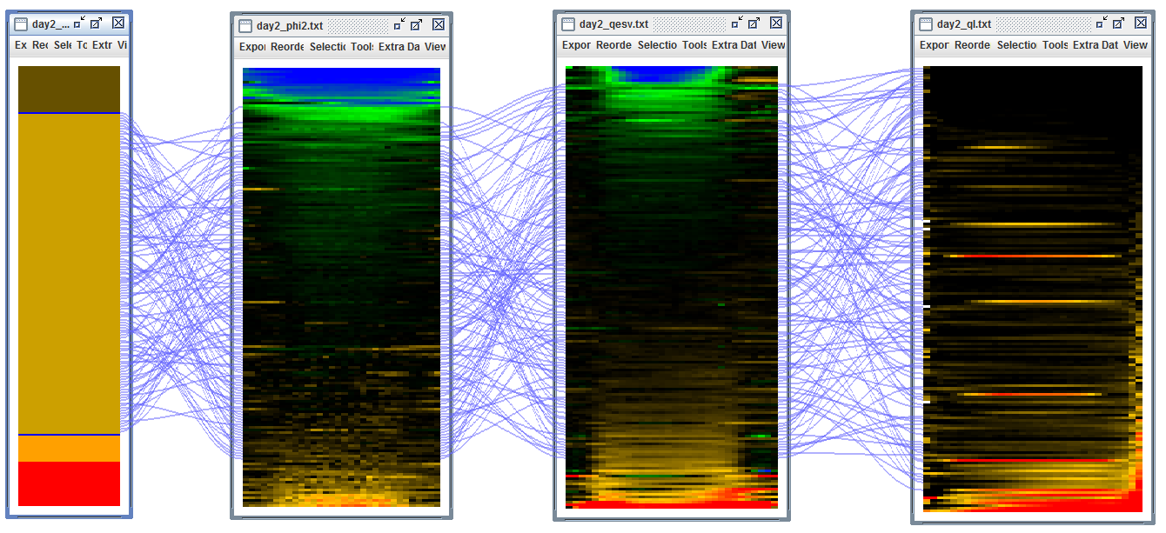

Sine light, cluster 3: low Phi2, low qE, high qI

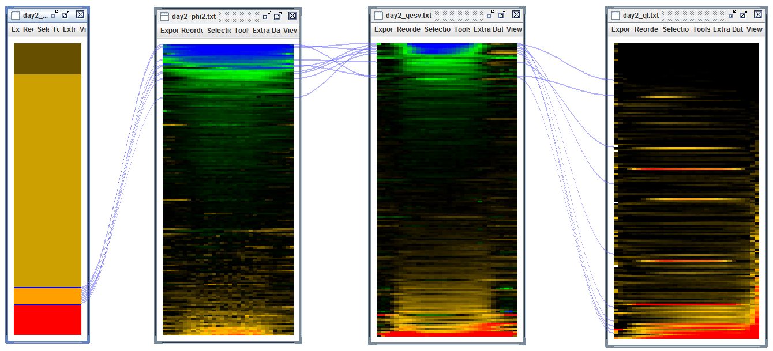

|  |  |
| --- | --- |
| Locus Identifier | Gene Model Description |
| AT1G65230 | Uncharacterized conserved protein (DUF2358); FUNCTIONS IN: molecular_function unknown; INVOLVED IN: biological_process unknown; LOCATED IN: chloroplast; EXPRESSED IN: 21 plant structures; EXPRESSED DURING: 13 growth stages; CONTAINS InterPro DOMAIN/s: Protein of unknown function DUF2358 (InterPro:IPR018790); Has 45 Blast hits to 45 proteins in 18 species: Archae - 0; Bacteria - 4; Metazoa - 0; Fungi - 0; Plants - 41; Viruses - 0; Other Eukaryotes - 0 (source: NCBI BLink). |
| AT3G46610 | Pentatricopeptide repeat (PPR-like) superfamily protein; CONTAINS InterPro DOMAIN/s: Pentatricopeptide repeat (InterPro:IPR002885); BEST Arabidopsis thaliana protein match is: Pentatricopeptide repeat (PPR) superfamily protein (TAIR:AT5G14350.1); Has 35826 Blast hits to 11282 proteins in 257 species: Archae - 3; Bacteria - 23; Metazoa - 290; Fungi - 374; Plants - 33823; Viruses - 0; Other Eukaryotes - 1313 (source: NCBI BLink). |
| AT1G73530 | RNA-binding (RRM/RBD/RNP motifs) family protein; FUNCTIONS IN: RNA binding, nucleotide binding, nucleic acid binding; INVOLVED IN: biological_process unknown; LOCATED IN: chloroplast; EXPRESSED IN: 22 plant structures; EXPRESSED DURING: 13 growth stages; CONTAINS InterPro DOMAIN/s: RNA recognition motif, RNP-1 (InterPro:IPR000504), Nucleotide-binding, alpha-beta plait (InterPro:IPR012677); BEST Arabidopsis thaliana protein match is: RNA-binding (RRM/RBD/RNP motifs) family protein (TAIR:AT5G54580.1); Has 7 Blast hits to 7 proteins in 2 species: Archae - 0; Bacteria - 0; Metazoa - 0; Fungi - 0; Plants - 7; Viruses - 0; Other Eukaryotes - 0 (source: NCBI BLink). |
| AT1G03600 | PSB27; FUNCTIONS IN: molecular_function unknown; INVOLVED IN: photosystem II repair; LOCATED IN: thylakoid, chloroplast thylakoid membrane, chloroplast thylakoid lumen, chloroplast photosystem II, chloroplast; EXPRESSED IN: 23 plant structures; EXPRESSED DURING: 13 growth stages; Has 273 Blast hits to 273 proteins in 82 species: Archae - 0; Bacteria - 114; Metazoa - 0; Fungi - 0; Plants - 63; Viruses - 0; Other Eukaryotes - 96 (source: NCBI BLink). |
| AT3G01480 | Encodes a chloroplast cyclophilin functioning in the assembly and maintenance of photosystem II (PSII) supercomplexes. |
| AT2G26550 | Encodes a heme oxygenase-like protein lacking the conserved histidine residue at the active site that is usually involved in heme-iron coordination. It is unable to bind and degrade heme. Mutant analyses suggest a role in photomorphogenesis. The protein can bind the heme precursor, proto IX, which could be biologically significant and point to a role in the regulation of the two tetrapyrrole biosynthetic pathways. |
| AT1G44575 | Encoding PSII-S (CP22), a ubiquitous pigment-binding protein associated with photosystem II (PSII) of higher plants. Involved in nonphotochemical quenching rather than in photosynthesis. Mutant has a normal violaxanthin cycle but has a limited capacity of quenching singlet excited chlorophylls and is tolerant to lipid peroxidation. |
| AT4G33520 | Encodes a putative metal-transporting P-type ATPase. |
| AT1G79040 | Encodes for the 10 kDa PsbR subunit of photosystem II (PSII). This subunit appears to be involved in the stable assembly of PSII, particularly that of the oxygen-evolving complex subunit PsbP. Mutants defective in this gene have reduced amounts of subunits PsbP and PsbQ in PSII. In turn, assembly of PsbR is dependent on the presence of PsbJ. |
| AT3G56040 | UDP-glucose pyrophosphorylase 3 (UGP3); FUNCTIONS IN: nucleotidyltransferase activity; INVOLVED IN: metabolic process; LOCATED IN: chloroplast; EXPRESSED IN: 22 plant structures; EXPRESSED DURING: 13 growth stages; CONTAINS InterPro DOMAIN/s: UTP--glucose-1-phosphate uridylyltransferase (InterPro:IPR002618); Has 215 Blast hits to 211 proteins in 91 species: Archae - 0; Bacteria - 18; Metazoa - 12; Fungi - 60; Plants - 85; Viruses - 0; Other Eukaryotes - 40 (source: NCBI BLink). |

Sine light, cluster 5: High Phi2, mid qE, mid qI

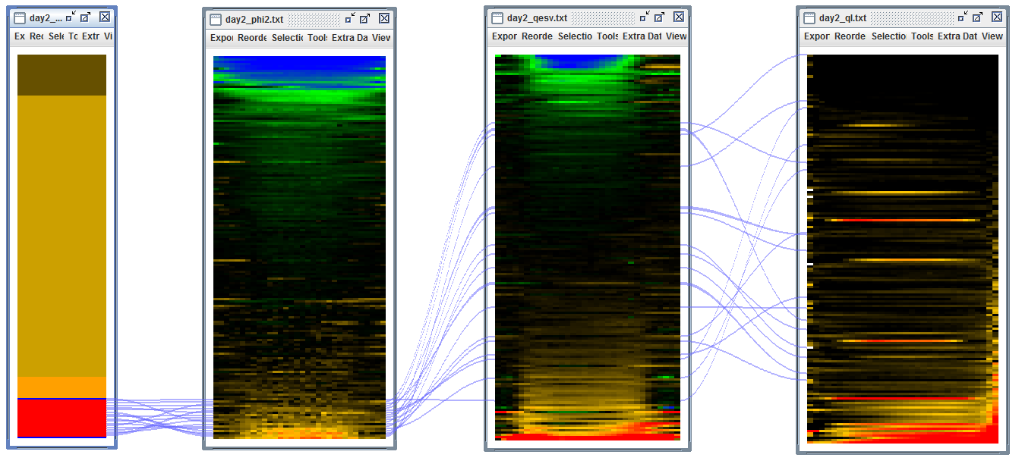

|  |  |
| --- | --- |
| Locus Identifier | Gene Model Description |
| AT1G20810 | FKBP-like peptidyl-prolyl cis-trans isomerase family protein; FUNCTIONS IN: FK506 binding, peptidyl-prolyl cis-trans isomerase activity; INVOLVED IN: protein folding; LOCATED IN: thylakoid lumen, chloroplast thylakoid lumen, chloroplast; EXPRESSED IN: 21 plant structures; EXPRESSED DURING: 13 growth stages; CONTAINS InterPro DOMAIN/s: Peptidyl-prolyl cis-trans isomerase, FKBP-type (InterPro:IPR001179); BEST Arabidopsis thaliana protein match is: FKBP-like peptidyl-prolyl cis-trans isomerase family protein (TAIR:AT3G10060.1); Has 1763 Blast hits to 1744 proteins in 606 species: Archae - 0; Bacteria - 1027; Metazoa - 95; Fungi - 57; Plants - 263; Viruses - 0; Other Eukaryotes - 321 (source: NCBI BLink). |
| AT2G21160 | Translocon-associated protein (TRAP), alpha subunit; INVOLVED IN: biological_process unknown; LOCATED IN: chloroplast thylakoid membrane, endoplasmic reticulum, plasma membrane, vacuole; EXPRESSED IN: 27 plant structures; EXPRESSED DURING: 15 growth stages; CONTAINS InterPro DOMAIN/s: Translocon-associated protein (TRAP), alpha subunit (InterPro:IPR005595); BEST Arabidopsis thaliana protein match is: Translocon-associated protein (TRAP), alpha subunit (TAIR:AT2G16595.1); Has 246 Blast hits to 246 proteins in 95 species: Archae - 0; Bacteria - 0; Metazoa - 141; Fungi - 24; Plants - 60; Viruses - 0; Other Eukaryotes - 21 (source: NCBI BLink). |
| AT1G54790 | GDSL-like Lipase/Acylhydrolase superfamily protein; FUNCTIONS IN: hydrolase activity, acting on ester bonds, carboxylesterase activity; INVOLVED IN: lipid metabolic process; LOCATED IN: endomembrane system; EXPRESSED IN: 16 plant structures; EXPRESSED DURING: 8 growth stages; CONTAINS InterPro DOMAIN/s: Lipase, GDSL (InterPro:IPR001087); BEST Arabidopsis thaliana protein match is: GDSL-like Lipase/Acylhydrolase superfamily protein (TAIR:AT3G05180.1); Has 35333 Blast hits to 34131 proteins in 2444 species: Archae - 798; Bacteria - 22429; Metazoa - 974; Fungi - 991; Plants - 531; Viruses - 0; Other Eukaryotes - 9610 (source: NCBI BLink). |
| AT5G62720 | Integral membrane HPP family protein; FUNCTIONS IN: molecular_function unknown; INVOLVED IN: biological_process unknown; LOCATED IN: integral to membrane, chloroplast inner membrane, chloroplast envelope; EXPRESSED IN: 22 plant structures; EXPRESSED DURING: 13 growth stages; CONTAINS InterPro DOMAIN/s: HPP (InterPro:IPR007065); BEST Arabidopsis thaliana protein match is: Integral membrane HPP family protein (TAIR:AT3G47980.1); Has 1507 Blast hits to 1507 proteins in 452 species: Archae - 0; Bacteria - 819; Metazoa - 0; Fungi - 49; Plants - 59; Viruses - 0; Other Eukaryotes - 580 (source: NCBI BLink). |
| AT1G74070 | Cyclophilin-like peptidyl-prolyl cis-trans isomerase family protein; FUNCTIONS IN: peptidyl-prolyl cis-trans isomerase activity; INVOLVED IN: protein folding; LOCATED IN: chloroplast thylakoid lumen, chloroplast; EXPRESSED IN: 20 plant structures; EXPRESSED DURING: 13 growth stages; CONTAINS InterPro DOMAIN/s: Cyclophilin-like (InterPro:IPR015891), Peptidyl-prolyl cis-trans isomerase, cyclophilin-type (InterPro:IPR002130); BEST Arabidopsis thaliana protein match is: cyclophilin 20-2 (TAIR:AT5G13120.1); Has 3262 Blast hits to 3261 proteins in 458 species: Archae - 0; Bacteria - 134; Metazoa - 1442; Fungi - 557; Plants - 702; Viruses - 0; Other Eukaryotes - 427 (source: NCBI BLink). |
| AT1G78915 | Tetratricopeptide repeat (TPR)-like superfamily protein; FUNCTIONS IN: binding; INVOLVED IN: biological_process unknown; LOCATED IN: chloroplast thylakoid membrane; CONTAINS InterPro DOMAIN/s: Tetratricopeptide-like helical (InterPro:IPR011990), Tetratricopeptide repeat-containing (InterPro:IPR013026), Tetratricopeptide repeat (InterPro:IPR019734). |
| AT2G37400 | Tetratricopeptide repeat (TPR)-like superfamily protein; FUNCTIONS IN: binding; INVOLVED IN: biological_process unknown; LOCATED IN: chloroplast thylakoid lumen, chloroplast envelope; EXPRESSED IN: 21 plant structures; EXPRESSED DURING: 12 growth stages; CONTAINS InterPro DOMAIN/s: Tetratricopeptide-like helical (InterPro:IPR011990), Tetratricopeptide repeat-containing (InterPro:IPR013026), Tetratricopeptide repeat (InterPro:IPR019734); BEST Arabidopsis thaliana protein match is: Tetratricopeptide repeat (TPR)-like superfamily protein (TAIR:AT3G53560.1); Has 2154 Blast hits to 1804 proteins in 477 species: Archae - 203; Bacteria - 1195; Metazoa - 120; Fungi - 25; Plants - 138; Viruses - 0; Other Eukaryotes - 473 (source: NCBI BLink). |
| AT1G15140 | FAD/NAD(P)-binding oxidoreductase; FUNCTIONS IN: oxidoreductase activity, copper ion binding; INVOLVED IN: oxidation reduction; LOCATED IN: thylakoid, chloroplast, chloroplast stroma, chloroplast envelope; EXPRESSED IN: 23 plant structures; EXPRESSED DURING: 15 growth stages; CONTAINS InterPro DOMAIN/s: Oxidoreductase FAD/NAD(P)-binding (InterPro:IPR001433), Ferredoxin reductase-type FAD-binding domain (InterPro:IPR017927), Oxidoreductase, FAD-binding domain (InterPro:IPR008333), Riboflavin synthase-like beta-barrel (InterPro:IPR017938), Phenol hydroxylase reductase (InterPro:IPR001221); BEST Arabidopsis thaliana protein match is: ferredoxin-NADP(+)-oxidoreductase 2 (TAIR:AT1G20020.3); Has 6042 Blast hits to 6042 proteins in 1578 species: Archae - 81; Bacteria - 4817; Metazoa - 13; Fungi - 213; Plants - 309; Viruses - 0; Other Eukaryotes - 609 (source: NCBI BLink). |
| AT1G50450 | Saccharopine dehydrogenase ; FUNCTIONS IN: binding, catalytic activity; INVOLVED IN: metabolic process; LOCATED IN: chloroplast; EXPRESSED IN: 21 plant structures; EXPRESSED DURING: 13 growth stages; CONTAINS InterPro DOMAIN/s: Saccharopine dehydrogenase / Homospermidine synthase (InterPro:IPR005097), NAD(P)-binding domain (InterPro:IPR016040); Has 1549 Blast hits to 1547 proteins in 500 species: Archae - 22; Bacteria - 980; Metazoa - 33; Fungi - 88; Plants - 49; Viruses - 0; Other Eukaryotes - 377 (source: NCBI BLink). |
| AT2G21530 | SMAD/FHA domain-containing protein ; INVOLVED IN: biological_process unknown; LOCATED IN: chloroplast thylakoid membrane, chloroplast stroma, chloroplast; EXPRESSED IN: guard cell; CONTAINS InterPro DOMAIN/s: SMAD/FHA domain (InterPro:IPR008984), Forkhead-associated (FHA) domain (InterPro:IPR000253); Has 459 Blast hits to 455 proteins in 163 species: Archae - 26; Bacteria - 275; Metazoa - 3; Fungi - 0; Plants - 102; Viruses - 0; Other Eukaryotes - 53 (source: NCBI BLink). |
| AT3G60370 | Encodes an immunophilin, FKBP20-2, that belongs to the FK-506 binding protein (FKBP) subfamily functioning as peptidyl-prolyl isomerases (PPIases) in protein folding. FKBP20-2 has a unique pair of cysteines at the C terminus and was found to be reduced by thioredoxin (Trx) (itself reduced by NADPH by means of NADP-Trx reductase). The FKBP20-2 protein, which contains only two of the five amino acids required for catalysis, showed a low level of PPIase activity that was unaffected on reduction by Trx. Genetic disruption of the FKBP20-2 gene provide evidence that FKBP20-2 participates specifically in the accumulation of the PSII supercomplex in the chloroplast thylakoid lumen by means of a mechanism that has yet to be determined. |
| AT1G67840 | Encodes a chloroplast sensor kinase (CSK) that shares common ancestors with cyanobacterial histidine sensor kinases. CSK is synthesised in the cytosol and imported into the chloroplast as a protein precusor. CSK is autophosphorylated and required for control of transcription of chloroplast genes by the redox state of an electron carrier connecting photosystems I and II. |
| AT1G74880 | Encodes subunit NDH-O of NAD(P)H:plastoquinone dehydrogenase complex (Ndh complex) present in the thylakoid membrane of chloroplasts. This subunit is thought to be required for Ndh complex assembly. |
| AT1G21750 | Encodes a protein disulfide isomerase-like (PDIL) protein, a member of a multigene family within the thioredoxin (TRX) superfamily; isoform contains non-consensus GA donor splice site at intron 9. Transcript levels for this gene are up-regulated in response to three different chemical inducers of ER stress (dithiothreitol, beta-mercaptoethanol, and tunicamycin). Neither AtIRE1-2 nor AtbZIP60 appear to be required for this response. |
| AT1G18730 | likely a subunit of the chloroplast NAD(P)H dehydrogenase complex, involved in PSI cyclic electron transport. Located on the thylakoid membrane. Mutant has impaired NAD(P)H dehydrogenase activity. |
| AT2G01140 | Aldolase superfamily protein; FUNCTIONS IN: fructose-bisphosphate aldolase activity; INVOLVED IN: response to oxidative stress, response to cadmium ion, pentose-phosphate shunt; LOCATED IN: mitochondrion, chloroplast, plastoglobule; EXPRESSED IN: 25 plant structures; EXPRESSED DURING: 15 growth stages; CONTAINS InterPro DOMAIN/s: Aldolase-type TIM barrel (InterPro:IPR013785), Fructose-bisphosphate aldolase, class-I (InterPro:IPR000741); BEST Arabidopsis thaliana protein match is: fructose-bisphosphate aldolase 2 (TAIR:AT4G38970.1); Has 4797 Blast hits to 4792 proteins in 909 species: Archae - 0; Bacteria - 723; Metazoa - 1159; Fungi - 8; Plants - 476; Viruses - 0; Other Eukaryotes - 2431 (source: NCBI BLink). |
| AT1G65260 | Encodes a protein required for thylakoid membrane formation. |

Fluctuating light, cluster 1: Low Phi2, low qE, mid qI

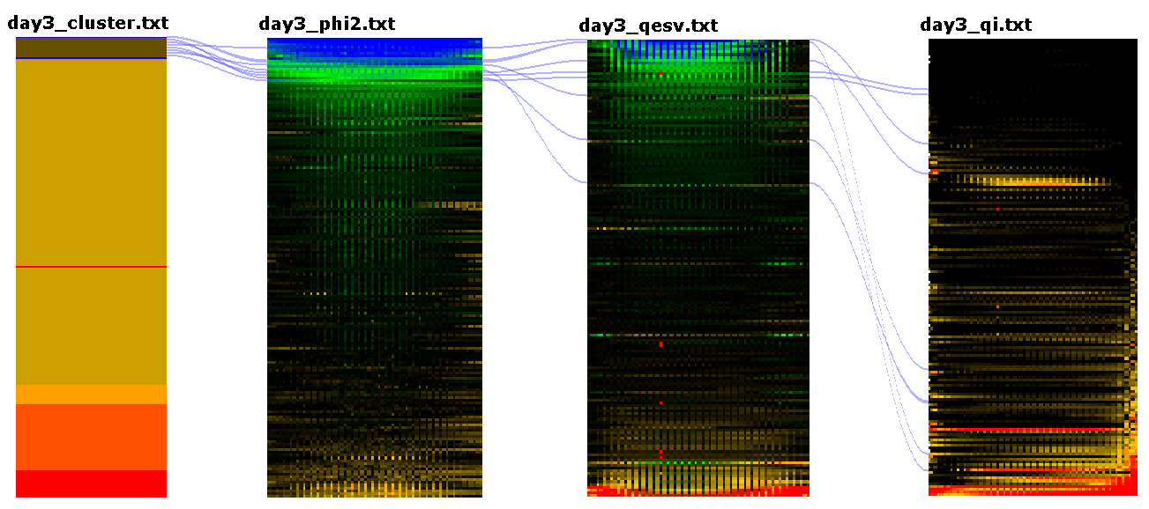

|  |  |
| --- | --- |
| Locus Identifier | Gene Model Description |
| AT3G46610 | Pentatricopeptide repeat (PPR-like) superfamily protein; CONTAINS InterPro DOMAIN/s: Pentatricopeptide repeat (InterPro:IPR002885); BEST Arabidopsis thaliana protein match is: Pentatricopeptide repeat (PPR) superfamily protein (TAIR:AT5G14350.1); Has 35826 Blast hits to 11282 proteins in 257 species: Archae - 3; Bacteria - 23; Metazoa - 290; Fungi - 374; Plants - 33823; Viruses - 0; Other Eukaryotes - 1313 (source: NCBI BLink). |
| AT1G73530 | RNA-binding (RRM/RBD/RNP motifs) family protein; FUNCTIONS IN: RNA binding, nucleotide binding, nucleic acid binding; INVOLVED IN: biological_process unknown; LOCATED IN: chloroplast; EXPRESSED IN: 22 plant structures; EXPRESSED DURING: 13 growth stages; CONTAINS InterPro DOMAIN/s: RNA recognition motif, RNP-1 (InterPro:IPR000504), Nucleotide-binding, alpha-beta plait (InterPro:IPR012677); BEST Arabidopsis thaliana protein match is: RNA-binding (RRM/RBD/RNP motifs) family protein (TAIR:AT5G54580.1); Has 7 Blast hits to 7 proteins in 2 species: Archae - 0; Bacteria - 0; Metazoa - 0; Fungi - 0; Plants - 7; Viruses - 0; Other Eukaryotes - 0 (source: NCBI BLink). |
| AT1G03600 | PSB27; FUNCTIONS IN: molecular_function unknown; INVOLVED IN: photosystem II repair; LOCATED IN: thylakoid, chloroplast thylakoid membrane, chloroplast thylakoid lumen, chloroplast photosystem II, chloroplast; EXPRESSED IN: 23 plant structures; EXPRESSED DURING: 13 growth stages; Has 273 Blast hits to 273 proteins in 82 species: Archae - 0; Bacteria - 114; Metazoa - 0; Fungi - 0; Plants - 63; Viruses - 0; Other Eukaryotes - 96 (source: NCBI BLink). |
| AT1G16880 | Encodes a ACT domain-containing protein. The ACT domain, named after bacterial aspartate kinase, chorismate mutase and TyrA (prephenate dehydrogenase), is a regulatory domain that serves as an amino acid-binding site in feedback-regulated amino acid metabolic enzymes. |
| AT4G25050 | encodes an acyl carrier protein predominantly expressed in leaves. Gene expression is upregulated by light. |
| AT1G32500 | Encodes a member of a heterogenous group of non-intrinsic ATP-binding cassette (ABC) proteins. Members of this group bear no close resemblance to each other nor to representatives of specific ABC protein subfamilies from other organisms. This grouping is arbitrary and will likely change upon acquisition of further data. |
| AT2G26550 | Encodes a heme oxygenase-like protein lacking the conserved histidine residue at the active site that is usually involved in heme-iron coordination. It is unable to bind and degrade heme. Mutant analyses suggest a role in photomorphogenesis. The protein can bind the heme precursor, proto IX, which could be biologically significant and point to a role in the regulation of the two tetrapyrrole biosynthetic pathways. |
| AT5G52440 | HCF106; nuclear gene for chloroplast. Thylakoid membrane delta pH translocation pathway component protein; related to Escherichia coli TatA and TatB |

Fluctuating light, cluster 2: mid Phi2, mid qE, mid qI

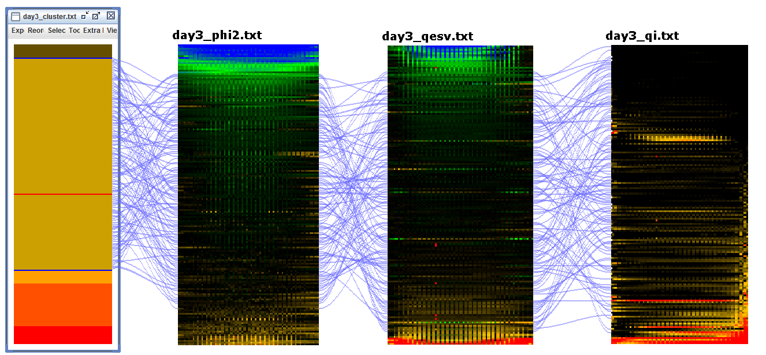

Fluctuating light, cluster 3: low Phi2, high qE, high qI

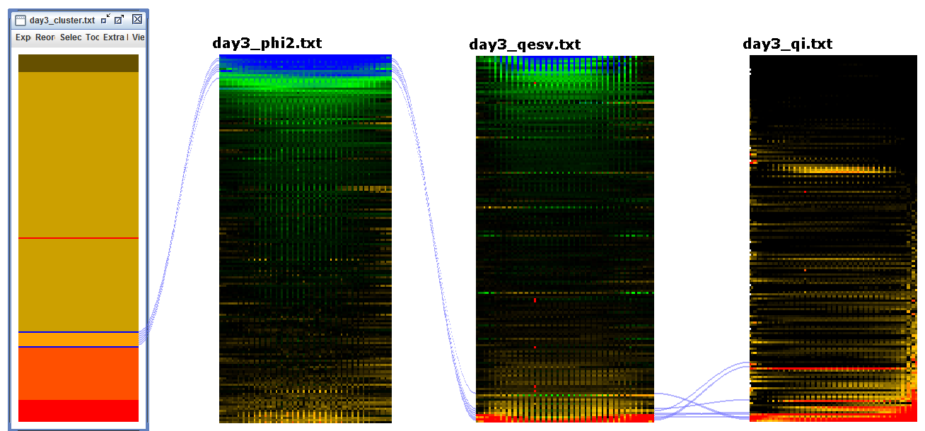

|  |  |
| --- | --- |
| Locus Identifier | Gene Model Description |
| AT3G17830 | Molecular chaperone Hsp40/DnaJ family protein; FUNCTIONS IN: unfolded protein binding, heat shock protein binding, ATP binding; INVOLVED IN: protein folding, response to heat; LOCATED IN: chloroplast; EXPRESSED IN: 8 plant structures; EXPRESSED DURING: 4 anthesis, F mature embryo stage, petal differentiation and expansion stage, E expanded cotyledon stage, D bilateral stage; CONTAINS InterPro DOMAIN/s: Molecular chaperone, heat shock protein, Hsp40, DnaJ (InterPro:IPR015609), HSP40/DnaJ peptide-binding (InterPro:IPR008971), Chaperone DnaJ, C-terminal (InterPro:IPR002939), Heat shock protein DnaJ, N-terminal (InterPro:IPR001623), Heat shock protein DnaJ, conserved site (InterPro:IPR018253), Heat shock protein DnaJ, cysteine-rich domain (InterPro:IPR001305), Chaperone DnaJ (InterPro:IPR012724), Heat shock protein DnaJ (InterPro:IPR003095); BEST Arabidopsis thaliana protein match is: Molecular chaperone Hsp40/DnaJ family protein (TAIR:AT1G80030.2); Has 28823 Blast hits to 28018 proteins in 3494 species: Archae - 196; Bacteria - 10926; Metazoa - 4489; Fungi - 2504; Plants - 2754; Viruses - 18; Other Eukaryotes - 7936 (source: NCBI BLink). |
| AT2G26360 | Mitochondrial substrate carrier family protein; FUNCTIONS IN: binding; INVOLVED IN: transport, mitochondrial transport, transmembrane transport; LOCATED IN: mitochondrial inner membrane, membrane; EXPRESSED IN: 23 plant structures; EXPRESSED DURING: 13 growth stages; CONTAINS InterPro DOMAIN/s: Mitochondrial carrier protein (InterPro:IPR002067), Mitochondrial substrate carrier (InterPro:IPR001993), Mitochondrial substrate/solute carrier (InterPro:IPR018108); BEST Arabidopsis thaliana protein match is: mitochondrial substrate carrier family protein (TAIR:AT2G35800.1); Has 17043 Blast hits to 12636 proteins in 416 species: Archae - 0; Bacteria - 6; Metazoa - 6988; Fungi - 5263; Plants - 3119; Viruses - 0; Other Eukaryotes - 1667 (source: NCBI BLink). |
| AT4G36810 | Encodes a protein with geranylgeranyl pyrophosphate synthase activity involved in isoprenoid biosynthesis. The enzyme appears to be targeted to the chloroplast in epidermal cells and guard cells of leaves, and in etioplasts in roots. |
| AT2G41680 | Encodes a NADPH thioredoxin reductase involved in chloroplast protection against oxidative damage. |
| AT4G25910 | Encodes a protein containing the NFU domain that may be involved in iron-sulfur cluster assembly. Part of a five member gene family, more closely related to NFU1 and 2 than to NFU4 and 5. Targeted to the chloroplast. |
| AT3G47450 | Encodes a protein with similarity to the bacterial YqeH GTPase required for proper ribosome assembly. In Arabidopsis, mutant analyses show that this protein regulates growth and hormonal signaling in plants. It also attenuates oxidative stress and reactive oxygen species (ROS). It also seems to be involved in regulating leaf senescence and cell death. This gene product is also involved in nitric oxide biosynthesis in response to ABA but not exogenous H2O2. This protein also appears to be required for proper plastid biogenesis. Levels of several plastid-localized proteins, including RBCL, ClpP1, and the MEP biosynthesis enzymes DXS and DXR are altered in rif1-1 mutants. This protein was originally characterized as a mitrochondrial-localized nitric oxide synthase, but, the synthase activity was later disproven. In addition, new studies with GFP fusion proteins and chloroplast import assays suggest that this protein is found in chloroplasts. |
| AT3G19490 | member of Na+/H+ antiporter-Putative family |

Fluctuating light, cluster 4: high phi2, mid qE, mid qI

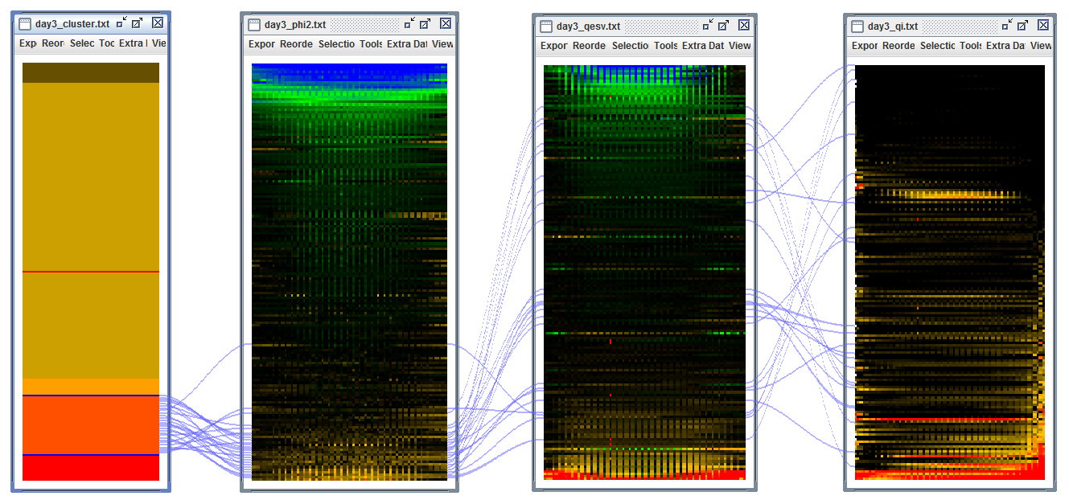

|  |  |
| --- | --- |
| Locus Identifier | Gene Model Description |
| AT3G25480 | Rhodanese/Cell cycle control phosphatase superfamily protein; FUNCTIONS IN: molecular_function unknown; INVOLVED IN: biological_process unknown; LOCATED IN: chloroplast thylakoid membrane, chloroplast; EXPRESSED IN: 23 plant structures; EXPRESSED DURING: 13 growth stages; CONTAINS InterPro DOMAIN/s: Rhodanese-like (InterPro:IPR001763); BEST Arabidopsis thaliana protein match is: thylakoid rhodanese-like (TAIR:AT4G01050.1); Has 72 Blast hits to 72 proteins in 16 species: Archae - 0; Bacteria - 0; Metazoa - 0; Fungi - 0; Plants - 72; Viruses - 0; Other Eukaryotes - 0 (source: NCBI BLink). |
| AT1G20810 | FKBP-like peptidyl-prolyl cis-trans isomerase family protein; FUNCTIONS IN: FK506 binding, peptidyl-prolyl cis-trans isomerase activity; INVOLVED IN: protein folding; LOCATED IN: thylakoid lumen, chloroplast thylakoid lumen, chloroplast; EXPRESSED IN: 21 plant structures; EXPRESSED DURING: 13 growth stages; CONTAINS InterPro DOMAIN/s: Peptidyl-prolyl cis-trans isomerase, FKBP-type (InterPro:IPR001179); BEST Arabidopsis thaliana protein match is: FKBP-like peptidyl-prolyl cis-trans isomerase family protein (TAIR:AT3G10060.1); Has 1763 Blast hits to 1744 proteins in 606 species: Archae - 0; Bacteria - 1027; Metazoa - 95; Fungi - 57; Plants - 263; Viruses - 0; Other Eukaryotes - 321 (source: NCBI BLink). |
| AT1G54790 | GDSL-like Lipase/Acylhydrolase superfamily protein; FUNCTIONS IN: hydrolase activity, acting on ester bonds, carboxylesterase activity; INVOLVED IN: lipid metabolic process; LOCATED IN: endomembrane system; EXPRESSED IN: 16 plant structures; EXPRESSED DURING: 8 growth stages; CONTAINS InterPro DOMAIN/s: Lipase, GDSL (InterPro:IPR001087); BEST Arabidopsis thaliana protein match is: GDSL-like Lipase/Acylhydrolase superfamily protein (TAIR:AT3G05180.1); Has 35333 Blast hits to 34131 proteins in 2444 species: Archae - 798; Bacteria - 22429; Metazoa - 974; Fungi - 991; Plants - 531; Viruses - 0; Other Eukaryotes - 9610 (source: NCBI BLink). |
| AT5G62720 | Integral membrane HPP family protein; FUNCTIONS IN: molecular_function unknown; INVOLVED IN: biological_process unknown; LOCATED IN: integral to membrane, chloroplast inner membrane, chloroplast envelope; EXPRESSED IN: 22 plant structures; EXPRESSED DURING: 13 growth stages; CONTAINS InterPro DOMAIN/s: HPP (InterPro:IPR007065); BEST Arabidopsis thaliana protein match is: Integral membrane HPP family protein (TAIR:AT3G47980.1); Has 1507 Blast hits to 1507 proteins in 452 species: Archae - 0; Bacteria - 819; Metazoa - 0; Fungi - 49; Plants - 59; Viruses - 0; Other Eukaryotes - 580 (source: NCBI BLink). |
| AT1G74070 | Cyclophilin-like peptidyl-prolyl cis-trans isomerase family protein; FUNCTIONS IN: peptidyl-prolyl cis-trans isomerase activity; INVOLVED IN: protein folding; LOCATED IN: chloroplast thylakoid lumen, chloroplast; EXPRESSED IN: 20 plant structures; EXPRESSED DURING: 13 growth stages; CONTAINS InterPro DOMAIN/s: Cyclophilin-like (InterPro:IPR015891), Peptidyl-prolyl cis-trans isomerase, cyclophilin-type (InterPro:IPR002130); BEST Arabidopsis thaliana protein match is: cyclophilin 20-2 (TAIR:AT5G13120.1); Has 3262 Blast hits to 3261 proteins in 458 species: Archae - 0; Bacteria - 134; Metazoa - 1442; Fungi - 557; Plants - 702; Viruses - 0; Other Eukaryotes - 427 (source: NCBI BLink). |
| AT1G78915 | Tetratricopeptide repeat (TPR)-like superfamily protein; FUNCTIONS IN: binding; INVOLVED IN: biological_process unknown; LOCATED IN: chloroplast thylakoid membrane; CONTAINS InterPro DOMAIN/s: Tetratricopeptide-like helical (InterPro:IPR011990), Tetratricopeptide repeat-containing (InterPro:IPR013026), Tetratricopeptide repeat (InterPro:IPR019734). |
| AT2G37400 | Tetratricopeptide repeat (TPR)-like superfamily protein; FUNCTIONS IN: binding; INVOLVED IN: biological_process unknown; LOCATED IN: chloroplast thylakoid lumen, chloroplast envelope; EXPRESSED IN: 21 plant structures; EXPRESSED DURING: 12 growth stages; CONTAINS InterPro DOMAIN/s: Tetratricopeptide-like helical (InterPro:IPR011990), Tetratricopeptide repeat-containing (InterPro:IPR013026), Tetratricopeptide repeat (InterPro:IPR019734); BEST Arabidopsis thaliana protein match is: Tetratricopeptide repeat (TPR)-like superfamily protein (TAIR:AT3G53560.1); Has 2154 Blast hits to 1804 proteins in 477 species: Archae - 203; Bacteria - 1195; Metazoa - 120; Fungi - 25; Plants - 138; Viruses - 0; Other Eukaryotes - 473 (source: NCBI BLink). |
| AT1G50450 | Saccharopine dehydrogenase ; FUNCTIONS IN: binding, catalytic activity; INVOLVED IN: metabolic process; LOCATED IN: chloroplast; EXPRESSED IN: 21 plant structures; EXPRESSED DURING: 13 growth stages; CONTAINS InterPro DOMAIN/s: Saccharopine dehydrogenase / Homospermidine synthase (InterPro:IPR005097), NAD(P)-binding domain (InterPro:IPR016040); Has 1549 Blast hits to 1547 proteins in 500 species: Archae - 22; Bacteria - 980; Metazoa - 33; Fungi - 88; Plants - 49; Viruses - 0; Other Eukaryotes - 377 (source: NCBI BLink). |
| AT2G21530 | SMAD/FHA domain-containing protein ; INVOLVED IN: biological_process unknown; LOCATED IN: chloroplast thylakoid membrane, chloroplast stroma, chloroplast; EXPRESSED IN: guard cell; CONTAINS InterPro DOMAIN/s: SMAD/FHA domain (InterPro:IPR008984), Forkhead-associated (FHA) domain (InterPro:IPR000253); Has 459 Blast hits to 455 proteins in 163 species: Archae - 26; Bacteria - 275; Metazoa - 3; Fungi - 0; Plants - 102; Viruses - 0; Other Eukaryotes - 53 (source: NCBI BLink). |
| AT4G19830 | FKBP-like peptidyl-prolyl cis-trans isomerase family protein; FUNCTIONS IN: FK506 binding, peptidyl-prolyl cis-trans isomerase activity; INVOLVED IN: protein folding; LOCATED IN: chloroplast thylakoid lumen; EXPRESSED IN: 22 plant structures; EXPRESSED DURING: 15 growth stages; CONTAINS InterPro DOMAIN/s: Peptidyl-prolyl cis-trans isomerase, FKBP-type (InterPro:IPR001179); BEST Arabidopsis thaliana protein match is: FKBP-like peptidyl-prolyl cis-trans isomerase family protein (TAIR:AT4G26555.1); Has 5413 Blast hits to 5325 proteins in 1280 species: Archae - 56; Bacteria - 2447; Metazoa - 955; Fungi - 366; Plants - 719; Viruses - 0; Other Eukaryotes - 870 (source: NCBI BLink). |
| AT1G16790 | ribosomal protein-related; FUNCTIONS IN: molecular_function unknown; INVOLVED IN: biological_process unknown; LOCATED IN: chloroplast thylakoid membrane, chloroplast, chloroplast envelope; EXPRESSED IN: 19 plant structures; EXPRESSED DURING: 11 growth stages; Has 10 Blast hits to 10 proteins in 6 species: Archae - 0; Bacteria - 0; Metazoa - 0; Fungi - 0; Plants - 10; Viruses - 0; Other Eukaryotes - 0 (source: NCBI BLink). |
| AT3G26080 | plastid-lipid associated protein PAP / fibrillin family protein; FUNCTIONS IN: structural molecule activity; INVOLVED IN: biological_process unknown; LOCATED IN: chloroplast thylakoid membrane, chloroplast; CONTAINS InterPro DOMAIN/s: Plastid lipid-associated protein/fibrillin (InterPro:IPR006843); BEST Arabidopsis thaliana protein match is: Plastid-lipid associated protein PAP / fibrillin family protein (TAIR:AT3G26070.1); Has 376 Blast hits to 374 proteins in 78 species: Archae - 0; Bacteria - 85; Metazoa - 0; Fungi - 0; Plants - 276; Viruses - 0; Other Eukaryotes - 15 (source: NCBI BLink). |
| AT3G60370 | Encodes an immunophilin, FKBP20-2, that belongs to the FK-506 binding protein (FKBP) subfamily functioning as peptidyl-prolyl isomerases (PPIases) in protein folding. FKBP20-2 has a unique pair of cysteines at the C terminus and was found to be reduced by thioredoxin (Trx) (itself reduced by NADPH by means of NADP-Trx reductase). The FKBP20-2 protein, which contains only two of the five amino acids required for catalysis, showed a low level of PPIase activity that was unaffected on reduction by Trx. Genetic disruption of the FKBP20-2 gene provide evidence that FKBP20-2 participates specifically in the accumulation of the PSII supercomplex in the chloroplast thylakoid lumen by means of a mechanism that has yet to be determined. |
| AT1G67840 | Encodes a chloroplast sensor kinase (CSK) that shares common ancestors with cyanobacterial histidine sensor kinases. CSK is synthesised in the cytosol and imported into the chloroplast as a protein precusor. CSK is autophosphorylated and required for control of transcription of chloroplast genes by the redox state of an electron carrier connecting photosystems I and II. |
| AT1G27510 | FUNCTIONS IN: DNA binding, nuclease activity; INVOLVED IN: response to singlet oxygen; LOCATED IN: thylakoid membrane; EXPRESSED IN: 22 plant structures; EXPRESSED DURING: 13 growth stages; CONTAINS InterPro DOMAIN/s: Protein of unknown function DUF3506 (InterPro:IPR021894), UvrB/UvrC protein (InterPro:IPR001943); BEST Arabidopsis thaliana protein match is: Protein of unknown function (DUF3506) (TAIR:AT4G33630.2); Has 287 Blast hits to 280 proteins in 95 species: Archae - 0; Bacteria - 15; Metazoa - 66; Fungi - 43; Plants - 121; Viruses - 0; Other Eukaryotes - 42 (source: NCBI BLink). |
| AT1G03850 | Encodes glutaredoxin ATGRXS13, required to facilitate Botrytis cinerea infection of Arabidopsis thaliana plants. Sylvain La Camera et al (2011, PMID:21756272) reported a third splice variant in addition to the two annotated in TAIR10. |
| AT1G05385 | Encodes a Psb27 homolog involved in photosystem II biogenesis. |
| AT1G74880 | Encodes subunit NDH-O of NAD(P)H:plastoquinone dehydrogenase complex (Ndh complex) present in the thylakoid membrane of chloroplasts. This subunit is thought to be required for Ndh complex assembly. |
| AT1G21750 | Encodes a protein disulfide isomerase-like (PDIL) protein, a member of a multigene family within the thioredoxin (TRX) superfamily; isoform contains non-consensus GA donor splice site at intron 9. Transcript levels for this gene are up-regulated in response to three different chemical inducers of ER stress (dithiothreitol, beta-mercaptoethanol, and tunicamycin). Neither AtIRE1-2 nor AtbZIP60 appear to be required for this response. |
| AT1G18730 | likely a subunit of the chloroplast NAD(P)H dehydrogenase complex, involved in PSI cyclic electron transport. Located on the thylakoid membrane. Mutant has impaired NAD(P)H dehydrogenase activity. |
| AT2G01140 | Aldolase superfamily protein; FUNCTIONS IN: fructose-bisphosphate aldolase activity; INVOLVED IN: response to oxidative stress, response to cadmium ion, pentose-phosphate shunt; LOCATED IN: mitochondrion, chloroplast, plastoglobule; EXPRESSED IN: 25 plant structures; EXPRESSED DURING: 15 growth stages; CONTAINS InterPro DOMAIN/s: Aldolase-type TIM barrel (InterPro:IPR013785), Fructose-bisphosphate aldolase, class-I (InterPro:IPR000741); BEST Arabidopsis thaliana protein match is: fructose-bisphosphate aldolase 2 (TAIR:AT4G38970.1); Has 4797 Blast hits to 4792 proteins in 909 species: Archae - 0; Bacteria - 723; Metazoa - 1159; Fungi - 8; Plants - 476; Viruses - 0; Other Eukaryotes - 2431 (source: NCBI BLink). |
| AT1G65260 | Encodes a protein required for thylakoid membrane formation. |
| AT2G01918 | Encode a protein homologous to each PQL protein. Mutational analysis indicates that PQL3 is also required for NDH activity. |
| AT1G30510 | Encodes a root-type ferredoxin:NADP(H) oxidoreductase. |

Fluctuating light, cluster 5: Low Phi2, low qE, high qI

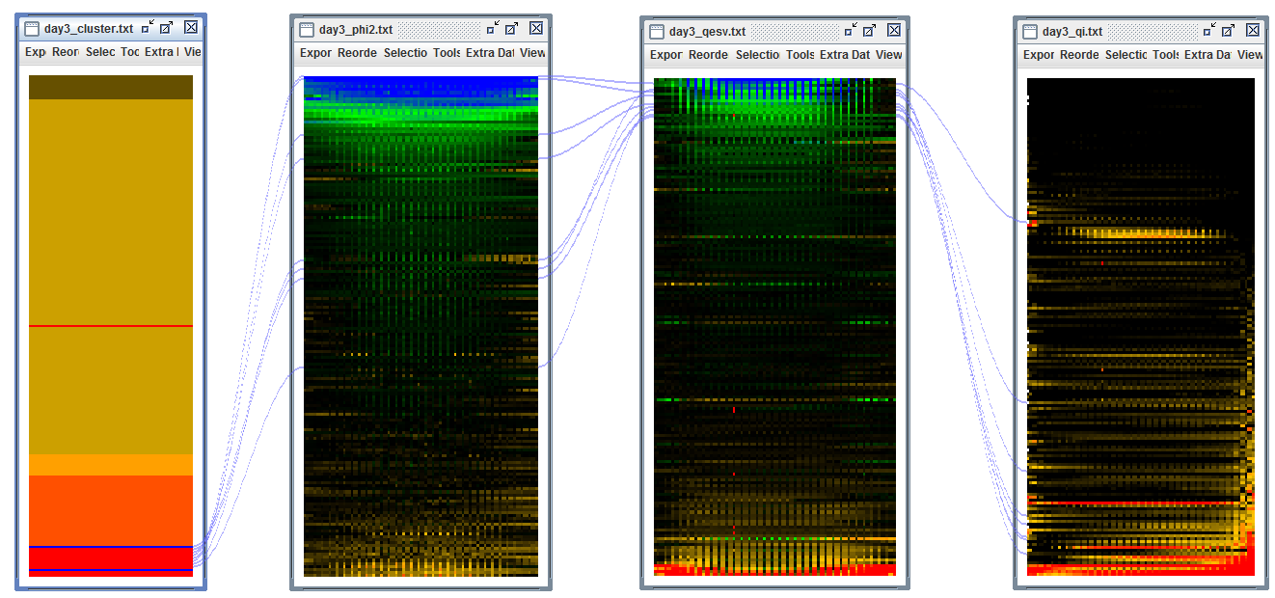

|  |  |
| --- | --- |
| Locus Identifier | Gene Model Description |
| AT1G65230 | Uncharacterized conserved protein (DUF2358); FUNCTIONS IN: molecular_function unknown; INVOLVED IN: biological_process unknown; LOCATED IN: chloroplast; EXPRESSED IN: 21 plant structures; EXPRESSED DURING: 13 growth stages; CONTAINS InterPro DOMAIN/s: Protein of unknown function DUF2358 (InterPro:IPR018790); Has 45 Blast hits to 45 proteins in 18 species: Archae - 0; Bacteria - 4; Metazoa - 0; Fungi - 0; Plants - 41; Viruses - 0; Other Eukaryotes - 0 (source: NCBI BLink). |
| AT5G07020 | proline-rich family protein; FUNCTIONS IN: molecular_function unknown; INVOLVED IN: biological_process unknown; LOCATED IN: thylakoid, chloroplast thylakoid membrane, chloroplast; EXPRESSED IN: 23 plant structures; EXPRESSED DURING: 13 growth stages; Has 30201 Blast hits to 17322 proteins in 780 species: Archae - 12; Bacteria - 1396; Metazoa - 17338; Fungi - 3422; Plants - 5037; Viruses - 0; Other Eukaryotes - 2996 (source: NCBI BLink). |
| AT3G01480 | Encodes a chloroplast cyclophilin functioning in the assembly and maintenance of photosystem II (PSII) supercomplexes. |
| AT1G44575 | Encoding PSII-S (CP22), a ubiquitous pigment-binding protein associated with photosystem II (PSII) of higher plants. Involved in nonphotochemical quenching rather than in photosynthesis. Mutant has a normal violaxanthin cycle but has a limited capacity of quenching singlet excited chlorophylls and is tolerant to lipid peroxidation. |
| AT4G33520 | Encodes a putative metal-transporting P-type ATPase. |
| AT5G01220 | involved in sulfolipid biosynthesis |
| AT1G54780 | Encodes a thylakoid lumen protein regulating photosystem II repair cycle. Has acid phosphatase activity. |
| AT3G56040 | UDP-glucose pyrophosphorylase 3 (UGP3); FUNCTIONS IN: nucleotidyltransferase activity; INVOLVED IN: metabolic process; LOCATED IN: chloroplast; EXPRESSED IN: 22 plant structures; EXPRESSED DURING: 13 growth stages; CONTAINS InterPro DOMAIN/s: UTP--glucose-1-phosphate uridylyltransferase (InterPro:IPR002618); Has 215 Blast hits to 211 proteins in 91 species: Archae - 0; Bacteria - 18; Metazoa - 12; Fungi - 60; Plants - 85; Viruses - 0; Other Eukaryotes - 40 (source: NCBI BLink). |

Fluctuating light, cluster 6: Low Phi2, low qE, mid qI

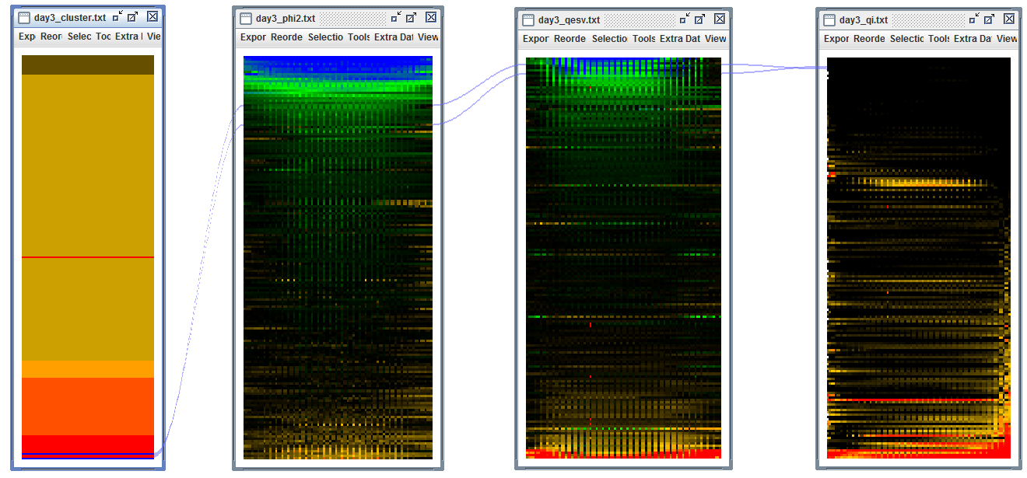

|  |  |
| --- | --- |
| AT1G71500 | Rieske (2Fe-2S) domain-containing protein; FUNCTIONS IN: oxidoreductase activity, 2 iron, 2 sulfur cluster binding; INVOLVED IN: oxidation reduction; LOCATED IN: chloroplast thylakoid membrane, chloroplast, chloroplast envelope; EXPRESSED IN: 23 plant structures; EXPRESSED DURING: 14 growth stages; CONTAINS InterPro DOMAIN/s: Rieske [2Fe-2S] iron-sulphur domain (InterPro:IPR017941); Has 295 Blast hits to 295 proteins in 102 species: Archae - 0; Bacteria - 166; Metazoa - 0; Fungi - 0; Plants - 94; Viruses - 0; Other Eukaryotes - 35 (source: NCBI BLink). |
| AT1G79040 | Encodes for the 10 kDa PsbR subunit of photosystem II (PSII). This subunit appears to be involved in the stable assembly of PSII, particularly that of the oxygen-evolving complex subunit PsbP. Mutants defective in this gene have reduced amounts of subunits PsbP and PsbQ in PSII. In turn, assembly of PsbR is dependent on the presence of PsbJ. |

**Pattern of Phi2, qE(SV), qI under three light conditions:**

flat HMM, LLM, MMM, LHH, LLH (outlier)

sine HMM, MMM, LHH, LLH

fluctuate HMM, LLM, MMM, LHH, LLH